LabView Code - Block Diagram
The overall block diagram of this system was given in the following image.
# 14
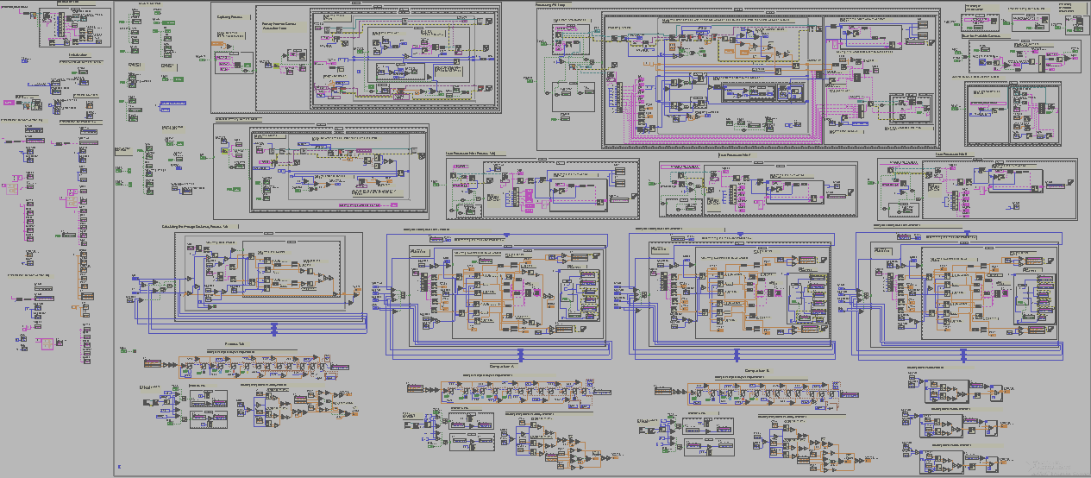
# 1
# 2
# 3
# 4
# 5
# 6
# 7
# 8
# 9
# 11
# 10
# 12
# 13
Figure 1. Overall Block Diagram
The Block Diagram of this system was protected by password. To open and edit the Block diagram enter a password: biomechanics.
The main code consists of many sub function. The result of some sub function can be seen directly in the system and others will be used as supporting sub function.
    - Load Default Path & Data
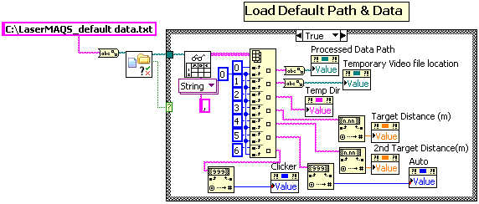
This function was use to load presetting data in Option Tab. The data that has been saved as default will be stored in LaserMAQS_default data.txt. When the system was run, the first thing the system will do was to load the default data if the data exist. If the data does not exist, the system will use the default value.

    - Save Default Path & Data
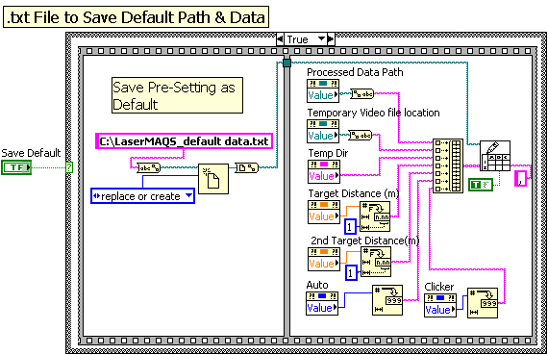
When Save default button was pressed, all the presetting data in the Adjustable Control on Option Tab will be saved into a text file.
    - Scan for Available Camera
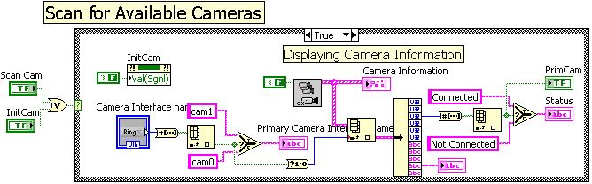
This function was used to determine whether the camera is connected or not. This function also shows the information of the camera in Option Tab.

    - Calculating the Primary Camera Scale (Calibrating)
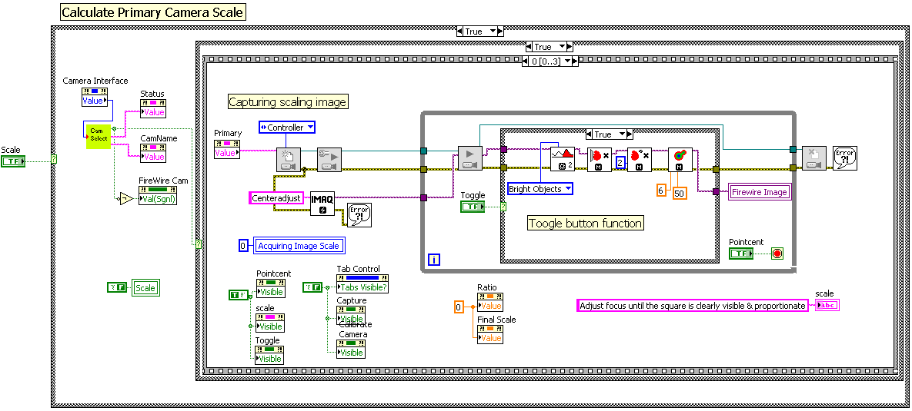
This code does a calibrating function. The calibration works by dividing the actual distance of the calibration card with the distance capture by camera. The result was in mm per pixel. Steps involve in calibrating the scale was given in the following flowchart.
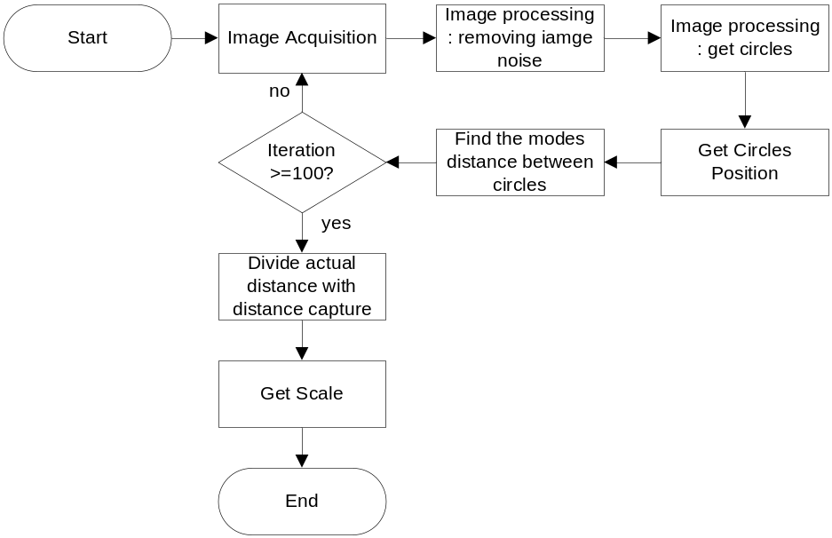
Figure 2. Flowchart of Acquiring Camera Scale (Calibrating)
    - Capturing Process
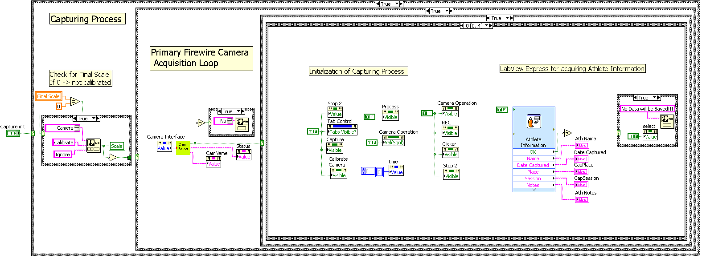
The Capturing Process will start by checking the calibration value. Value of zero in Final scale means that system was not calibrated yet and calibrated was required.
This system also stores other information into temporary CSV file like: Athlete Information, Pre-setup information values, timing per frame and clicker signal.
In capturing process, acquired images were stored in AVI format. The purpose of storing it was to increase the number of frame per second.
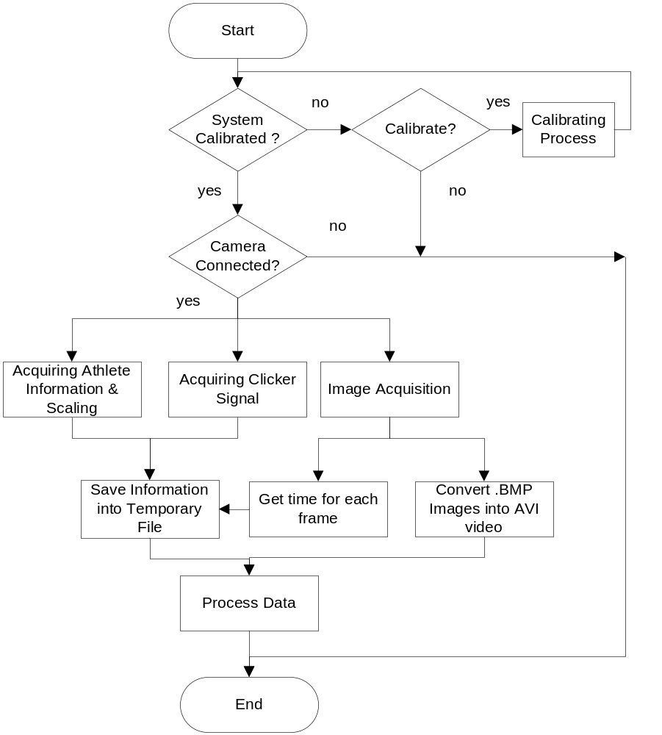
Figure 3. Flowchart of Capturing Process

5.1 Acquiring Time per Frame, Image and Clicker Signal
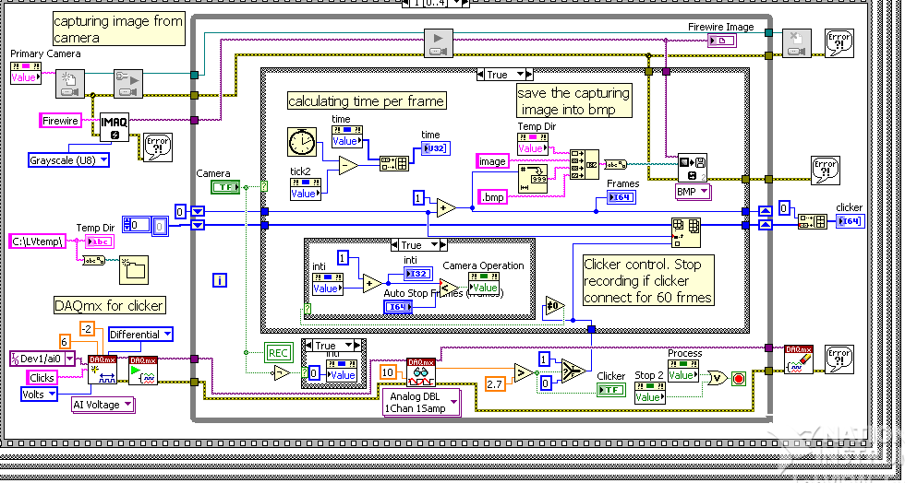
Time per frame can be obtained by using tick count. The time was then stored in a variable called time.
Images were acquired from camera and saved directly into temporary folder called LVtemp. These images will then be stored in AVI video in next sequence.
When the clicker touches the base, Clicker transmitter will send signal to the receiver. DAQ card will receive a high voltage each time receiver receive signal. This voltage will be compared by LabView. A signal with voltage higher than 2.7 V will be considered as high “1”. This signal will be stored into a variable for called clicker. All of the information about timing and clicker signal will be stored in temporary file for further process.

5.2 Convert BMP Images into AVI Video
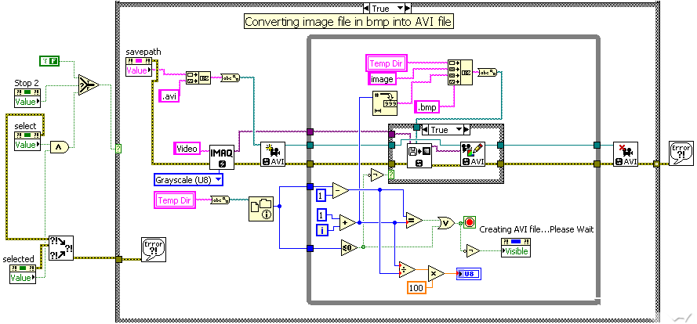
Storing of images into AVI can be done by the above block diagram. The purpose of not processing the images directly was because processing the images will slower the capturing the image that will cause in the reduction of frames number per second. The AVI file will be stored into temporary folder and the images will be deleted automatically after this process has been done.
    - Process Data
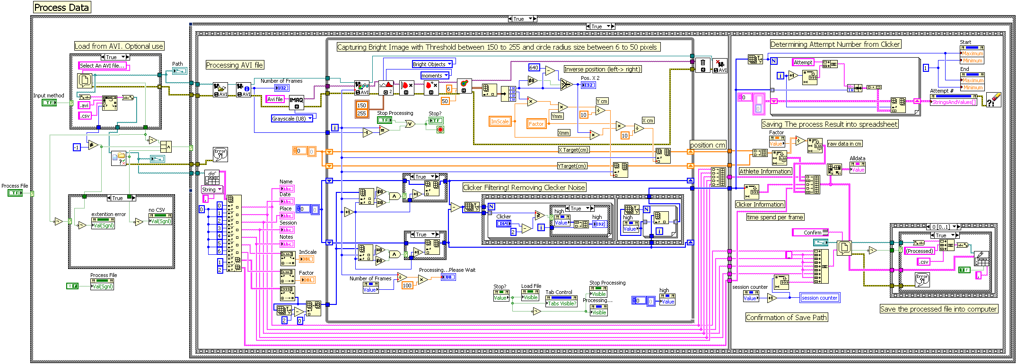
Processing of the data involve a lot of function that can be summarized into the following flowchart.
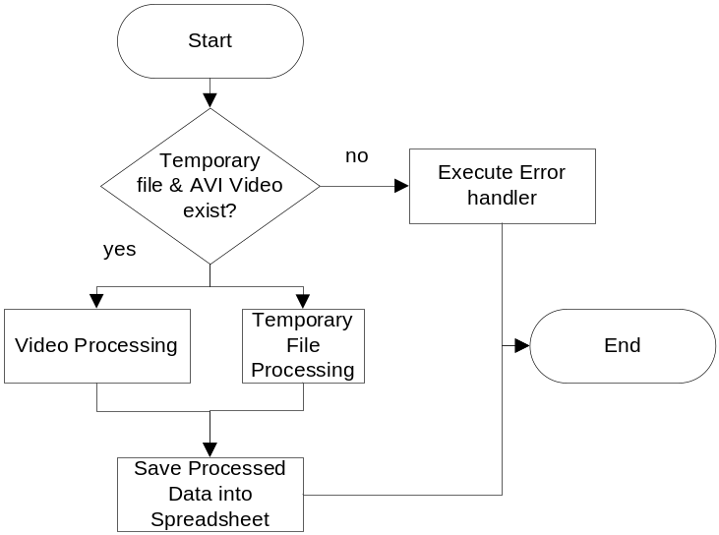
Figure 4. Flowchart of Processing Data

6.1 Checking for the Existence of Temporary file and AVI file
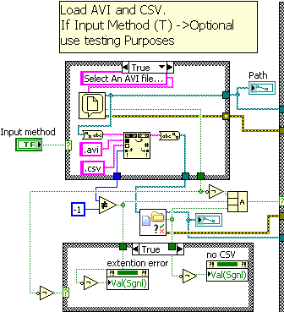
To process data, two files need to be exit. They were Temporary CSV file and AVI Video file. This program was used to check the existence of the two files. When the process was continued from Capturing Process, these two files should be available. But for testing purpose, the user was able to load the separate AVI and Temporary CSV file from computer. This function was not that important since the testing purpose was disabled.
6.2 Video Processing
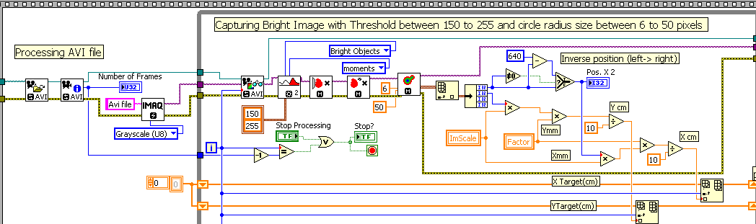
Video processing was the process of extracting image from AVI frame by frame and process the image by using image processing technique. The whole video processing will be shown on the flowchart given bellow.
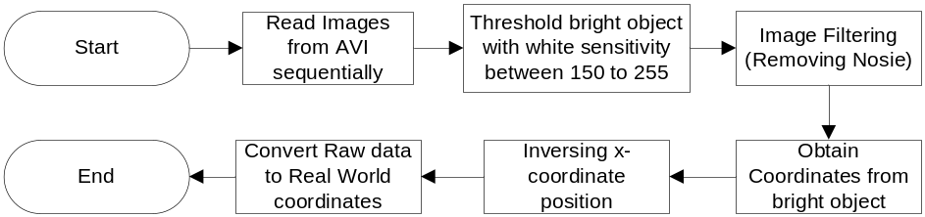
Figure 5.Flowchart for video processing
Since the image captured by the camera was set to greyscale, the result of camera will be black and white. The laser beam will result in bright object in the secondary target card with either circle or ellipse shape. LabView will obtain an object position with a circle or ellipse shape between 6 to 50 pixels. The coordinates of the circle centre point will be recorded as the position of the laser.
One problem of using a camera to capture position was the reverse image in x-coordinate system. When object is moving left, camera will show that the object is moving right. To solve this problem, x-coordinate values need to be reversed. The width size of camera resolution can be used to reverse the x-coordinate. The camera has a resolution of 640 x 480. The position of x-coordinate can be reverse easily by deducting each of x-coordinate position captured by 640.
After the process above, raw data will be obtained. Raw data is a data that has not been process yet. This raw data will then be converted into real world coordinate by multiplying the raw data by image scale and ratio between actual target and secondary target.
This ratio between the actual target and secondary target was obtained by using a similar triangle concept. Based on this concept, movement of 1 mm in secondary target will result on movement of 70 mm in actual target if the distance between the archer and secondary target is 1 meter and distance between archer and actual target is 70 meter.
6.3 Temporary File Processing
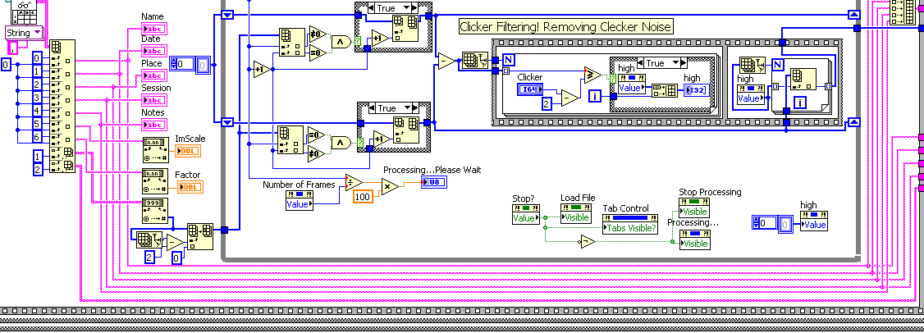
This function will extract all information from the temporary file and process it. The Processing of Temporary File will be shown in the following flowchart.
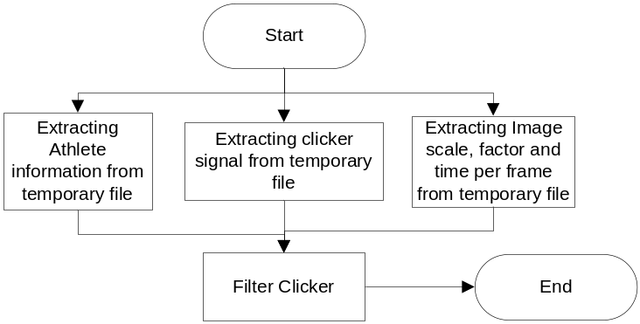
Figure 6.Flowchart for video processing
Main processing part of the Temporary File was in the clicker. The clicker need to be filtered to eliminate noise.
When an arrow was loaded to the bow, some gap will be created between the arrow and the clicker. This gap will cause the clicker transmitter not transmitting signal. But due to the vibration in the arrow, clicker the arrow might touch the clicker base that causes the transmitter to transmit signal and create noise. With the clicker filtering, user will be able to filter the noise based on filtering rate. Received signals that have values less than filtering rate will be considered as noise.

6.4 Saving Process Data into Spreadsheet
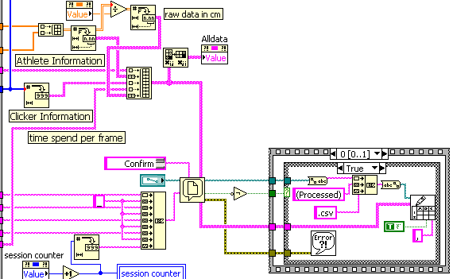
This program collects all information that has been processed and stores it into spreadsheet CSV file.
    - Plotting Data and Updating Values
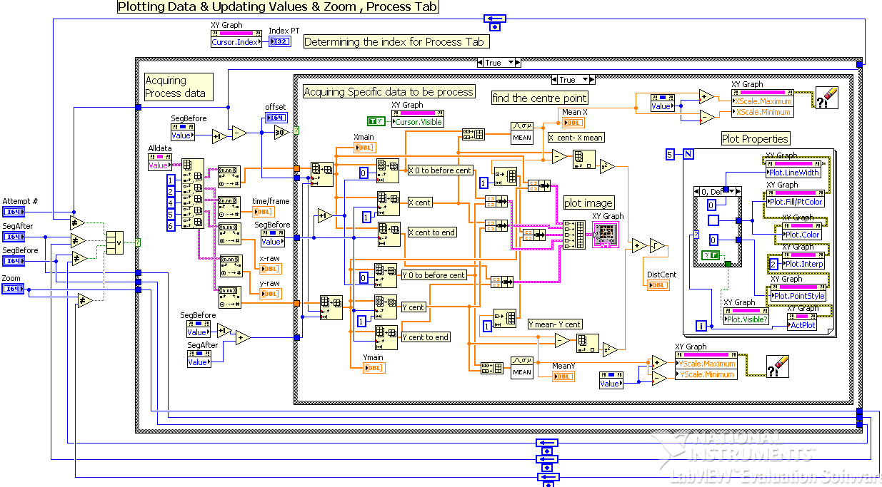
There were three graphs on this system; Process Tab graph, Comparison A graph and Comparison B graph. Process Tab graph has slightly more information to be displayed. All of these graphs use exactly the same technique to plot the lines. Because of that, explanation of the code will only be made for process tab graph.
The Block diagram was used to plot the processed data. The data that has been processed will contain Athlete information, captured pointer positions, Clickers position, time per frame and raw data. All of this information was stored in a variable called Alldata.
Clicker position of each attempt will be used to plot a point. This is the point when the arrow was released. From this point, it will take user defined frames values (before attempt and after attempt) to plot the complete graph. If user enters 50 frames before attempt, user will be able to see the movement of bow 50 frames before it was released. Same goes to 50 frames after released. The movement of archer before the arrow was released will be indicated by green line and after released movement will be indicated by blue line. The average of all coordinates values before the arrow was released will be the centre point of the target indicated by red dot.
Before all of the lines were plotted, this system will plot a dummy invisible line with a range of before attempt and after attempt. The purpose line was to get the indexing of the graph.
The property node of the graph was controlled by for loop. This property node has function to determine the visibility of the graph, colour of the line, shape of the line, width of the line and the active plot.
Distance at clicker can be obtained directly in this block diagram. It was calculated by taking the resultant of middle position with the position of clicker.
This function will update itself each time Attempt ring property, zoom slider or Frames to select changed.
    - Plotting Target as Background
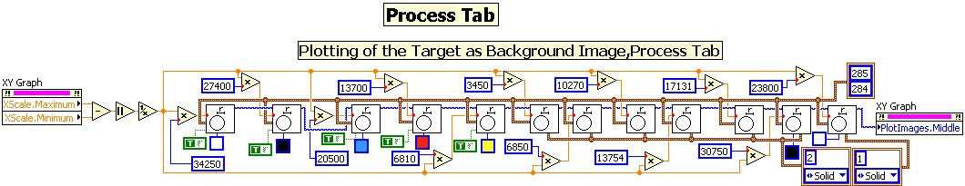
This block diagram was used to plot the background image of the target. The radius of the circles were obtained by trial and error so that each of the circle will have the multiply of 6. The images were then plotted into the middle of the graph.

    - Graph Indexing
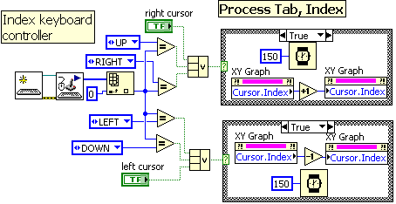
The graph Indexing was controlled by cursor on the graph, indexing button and keyboard. Wait function inside the case structure was used to give a delay of 150ms each time the key was pressed.

    - Distance Travelled
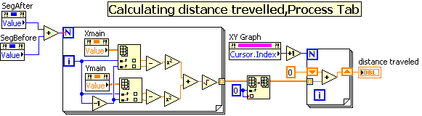
Distance travelled was obtained based on the indexing. This system will calculate the distance travelled from index 0 to index shown in the indexing box.

    - Calculating Aiming Distance and Velocity
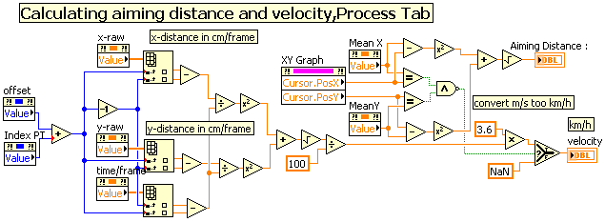
Aiming Distance was obtained by taking the radius of cursor position to the centre point of the graph while Velocity was obtained from the laser movement in the secondary target (not velocity of actual target). To obtain the velocity at secondary target, raw data was used. The velocity in meter per second can be obtained by dividing distance travelled between previous and present frames by 100 and divide it by the time taken for each frame. The result was then multiplied by 3.6 to convert it from meter per second into kilometer per hour.

    - Calculating the Average Distance between Attempts
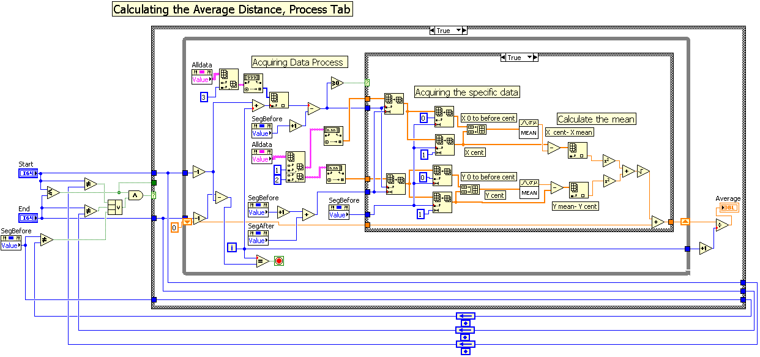
The average between attempts was obtained by taking the average of distance at clicker chosen by user. If user enters 1 for the start value and 5 for the end value, the system will calculate the average value of distance at clicker. This function was only available in the process tab.

    - Load Processed File
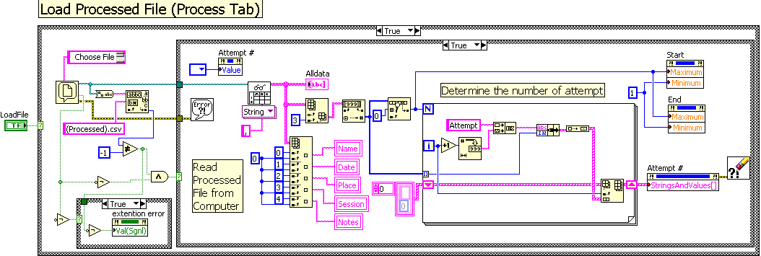
This function was used to load the processed CSV file that has been saved inside your computer indicated by “(Processed)” sentence at the back of the file name. When Load button was pressed, dialog box will be appear to ask user to choose processed file. If user enters a wrong file, an extension error will pop up in the system.
This function will extract all of the information inside the file and put it into a variable called Alldata to be further processed. Number of attempt was determined by the number of clicker values inside the file.
    - Error Handlers
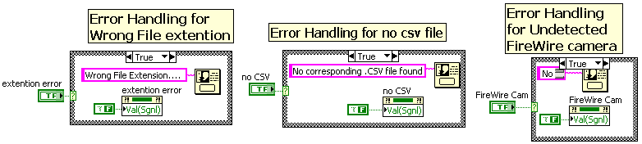
There were 3 error handlers in this system. The error handlers were use to pop up an error message when error was found or when the device was not detected.

    - Scan Camera (SubVi)
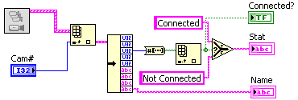
This was a simple SubVi that was used to check the status of camera connection and camera name. This subvi was almost the same with Scan for Available Camera shown above. It will be a good idea to make this function as subvi since this function was often used.

